MOCK -3

1. Implement a stack using a list in Python. Include the necessary methods such as push, pop, and isEmpty.

class Node:

    def __init__(self, data):

        self.data = data

        self.next = None

class Stack:

    def __init__(self):

        self.head = None

    def isempty(self):

        if self.head == None:

            return True

        else:

            return False

    def push(self, data):

        if self.head == None:

            self.head = Node(data)

        else:

            newnode = Node(data)

            newnode.next = self.head

            self.head = newnode

    def pop(self):

        if self.isempty():

            return None

        else:

            popped = self.head

            self.head = self.head.next

            popped.next = None

            return popped.data

    def peek(self):

        if self.isempty():

            return None

        else:

            return self.head.data

    def display(self):

        iternode = self.head

        if self.isempty():

            print("Stack Underflow")

        else:

            while(iternode != None):

                print(iternode.data, end = "")

                iternode = iternode.next

                if(iternode != None):

                    print(" -> ", end = "")

            return

if __name__ == "__main__":

    MyStack = Stack()

    MyStack.push(10)

    MyStack.push(25)

    MyStack.push(37)

    MyStack.push(49)

    MyStack.push(90)

    MyStack.display()

    print("\n Top element is ", MyStack.peek())

    MyStack.pop()

    MyStack.pop()

    MyStack.display()

    print("\nTop element is ", MyStack.peek())

O/P:

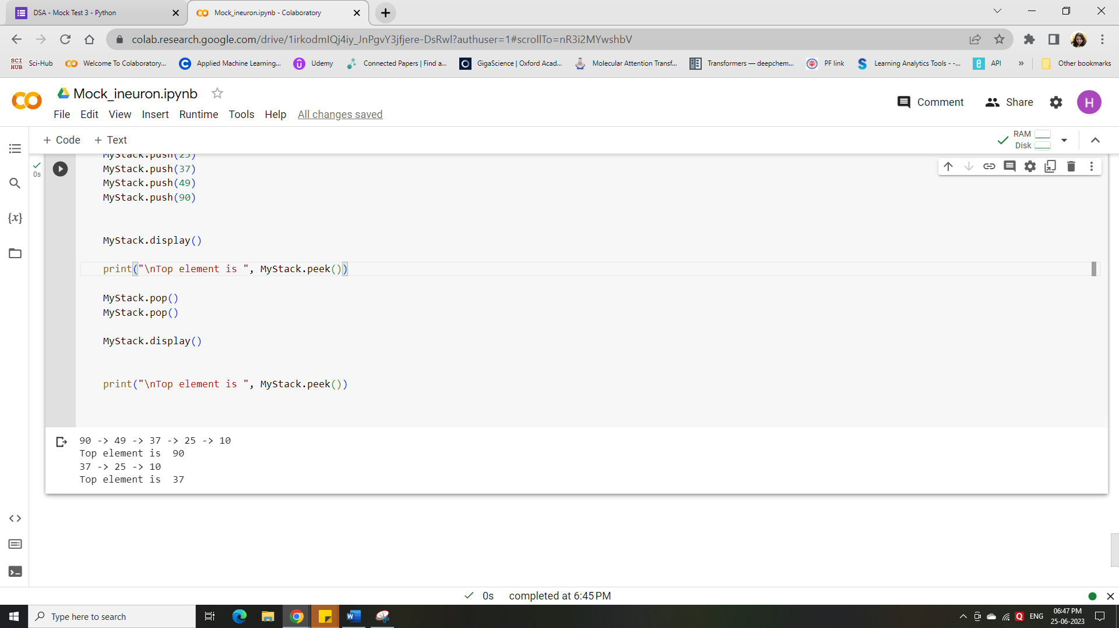

1. Implement a queue using a list in Python. Include the necessary methods such as enqueue, dequeue, and isEmpty.

q=[]

def isempty():

  if q == None:

    print("Queue is empty")

  elif len(q)== display().size:

    print("Queue is Full!!!!")

def Enqueue():

        element=input("Enter the element:")

        q.append(element)

        print(element,"is added to the Queue!")

def dequeue():

    if not q:# or if len(stack)==0

        print("Queue is Empty!!!")

    else:

        e=q.pop(0)

        print("element removed!!:",e)

def display():

    print(q)

    size=int(input("Enter the size of Queue:"))

    while True:

        print("Select the Operation:1.Check 2.Add 3.Delete 4.Display 5.Quit")

        choice=int(input())

        if choice==1:

            isempty()

        elif choice==2:

            Enqueue()

        elif choice==3:

            dequeue()

        elif choice==4:

            display()

        elif choice==5:

          break

        else:

            print("Invalid Option!!!")

display()

O/P:

